**DAILY ONLINE ACTIVITIES SUMMARY**

|  |  |  |  |  |  |  |  |  |
| --- | --- | --- | --- | --- | --- | --- | --- | --- |
| **Date:** | **28-5-2020** | | | | | **Name:** | **Prajna** | |
| **Sem & Sec** | **8th sem ‘B’** | | | | | **USN:** | **4AL16CS067** | |
| **Online Test Summary** | | | | | | | | |
| **Subject** | | **SMS** | | | | | | |
| **Max. Marks** | | **60** | | **Score** | | | **0** | |
| **Certification Course Summary** | | | | | | | | |
| **Course** | **Getting started: Hadoop** | | | | | | | |
| **Certificate Provider** | | | **Great Learning** | | **Duration** | | | **30min** |
| **Coding Challenges** | | | | | | | | |
| **Problem Statement:**1**.** Write a python program to check given substring is present in string | | | | | | | | |
| **Status: Completed** | | | | | | | | |
| **Uploaded the report in GitHub**  **GitHub link:** | | | | | **Yes**  **https://github.com/alvas-education-foundation/prajna_k** | | | |
| **If yes Repository name** | | | | | **prajna_k** | | | |
| **Uploaded the report in slack** | | | | | **yes** | | | |

Online Test Details: (Attach the snapshot and briefly write the report for the same)

Certification Course Details: (Attach the snapshot and briefly write the report for the same)

Coding Challenges Details: (Attach the snapshot and briefly write the report for the same)

1)online test

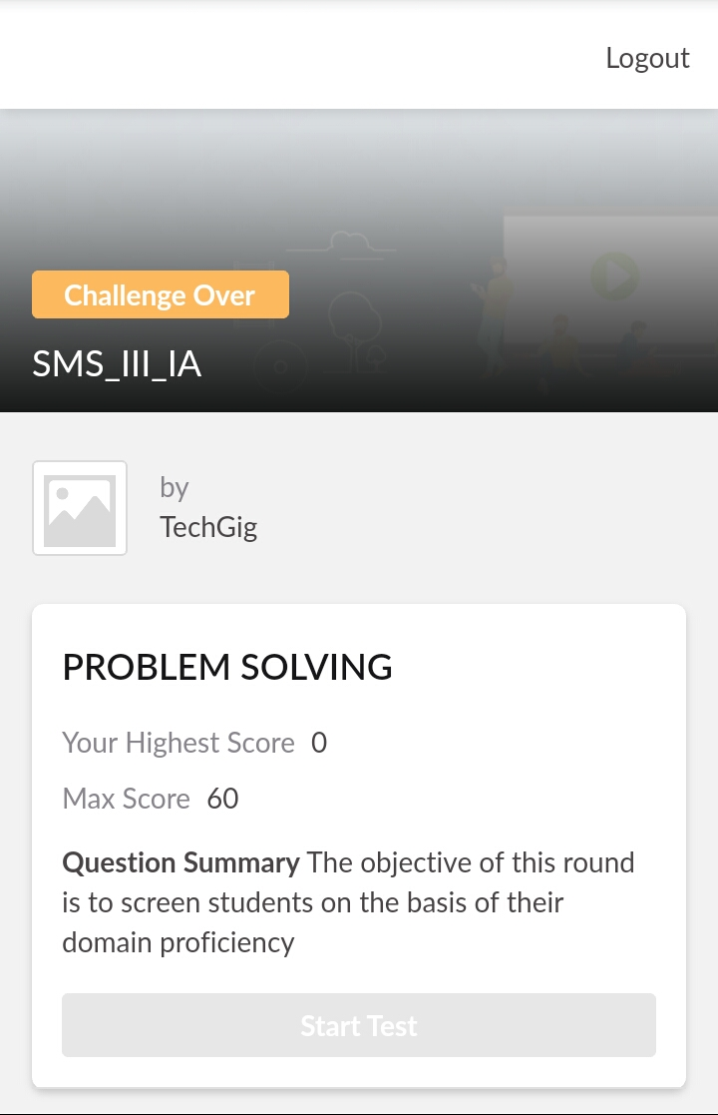

2) certification course

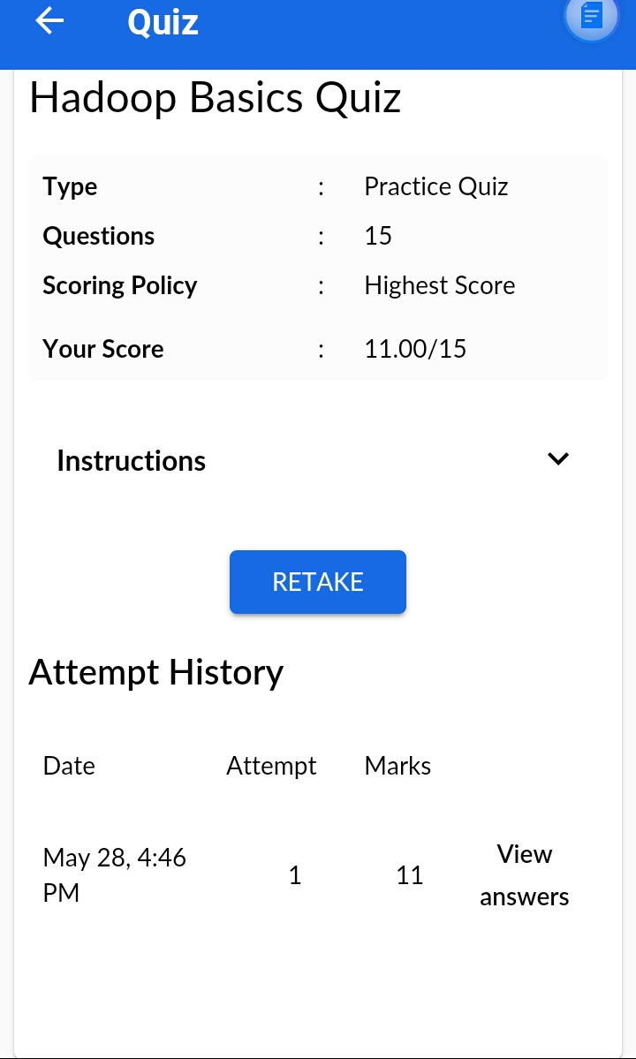

3) coding challenges

**Program 1**

|  |
| --- |
| def check(str1,sstr):  if (str1.find(sstr) == -1): |
| print(sstr,"IS NOT PRESENT IN THE GIVEN STRING") |
| else: |
| print(sstr,"IS PRESENT IN THE GIVEN STRING") |
| # Driver code |
| str1 = input("Enter the string ::>") |
| sstr=input("Enter Substring ::>") |
| check(str1, sstr) |

|  |
| --- |
|  |
|  |  |
|  |  |
|  |  |
|  |  |
|  |  |